**Analysis**

**Discipline Document**

**INF-F Analysis and Software Design**

**Project: HHS Term Planning**

**Date: 12-3-2014**

**Owner: *Munaf, Arif. van der Meer, Tim***

**Version: 0.1**

**Document History**

**Revision History**

|  |  |  |
| --- | --- | --- |
| **Version** | **Revision date** | **Summary of changes** |
| 0.1 | 10-3-2014 | Added analysis class diagram |
| 0.2 | 12-3-2014 | Added analysis packages |
| 0.3 | 13-3-2014 | Updated class diagram to reflect packages |
| 0.4 | 25-3-2014 | Updated class diagram and added sequence diagrams |
| 1.0 | 7-4-2014 | Finalized document |

**Distribution**

This document is intended for:

|  |  |  |  |
| --- | --- | --- | --- |
| **Name** | **Function** | **Date of issue** | **Version** |
| Client | project owner | 7-4-2014 | 1.0 |
| Indian Coding Company | implementation of project | 7-4-2014 | 1.0 |

**Table of Contents**

**1.** **Introduction**

**2.** **Analysis packages**

**3.** **Analysis class diagram**

**4.** **Analysis use case realisations**

**1. Introduction**

This document provides a view on the baseline of our software structure. The package analysis describes a general overview of segments used in the coding. The analysis diagram contains the essential classes that describe the essence of the systems. The diagrams in chapter 4 are meant to illustrate certain aspects of the system not immediately clear from the analysis diagram.

**2. Analysis packages**

Four different analysis packages have been identified,

* Task, containing all classes necessary for managing tasks and activities
* Location, contained in the Task package, specifies locations and their types
* Course, containing classes used for managing course parameters, groups and teaching units
* Teacher, specifying classes dealing with specializations and teachers

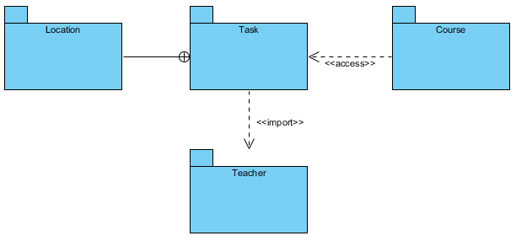

**3. Analysis class diagram**

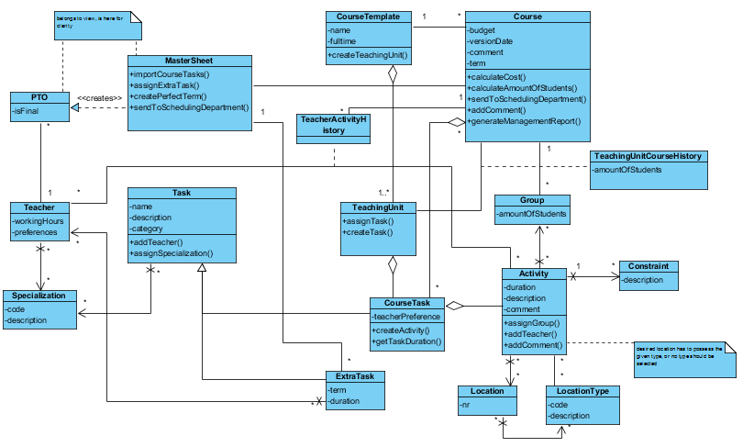

**4. Analysis use case realizations**

This diagram shows the process of adding a teacher to a task, making sure the teacher has the correct specializations.

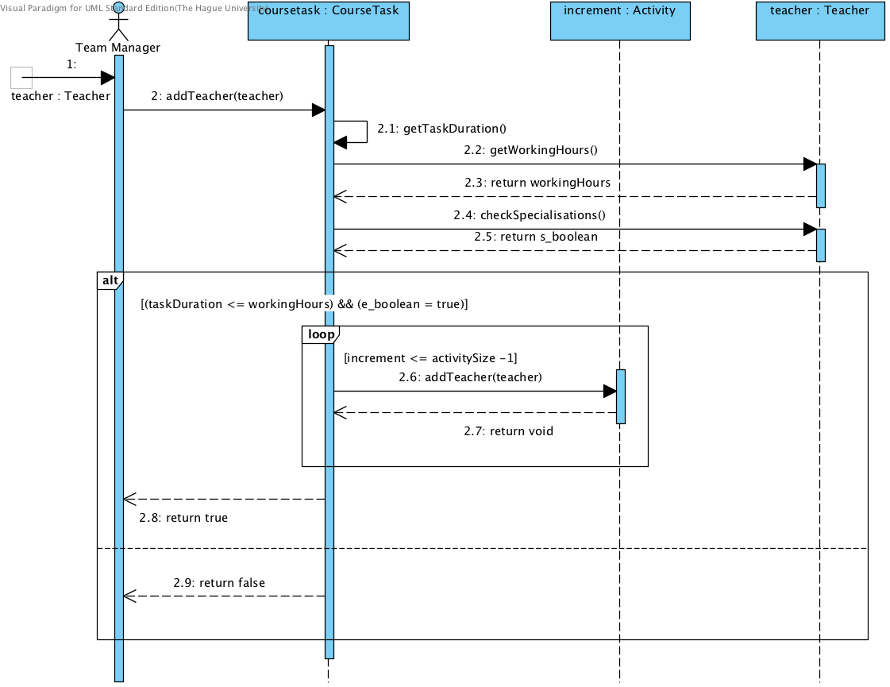

This diagram shows how the course manager goes about designing a course parameter.

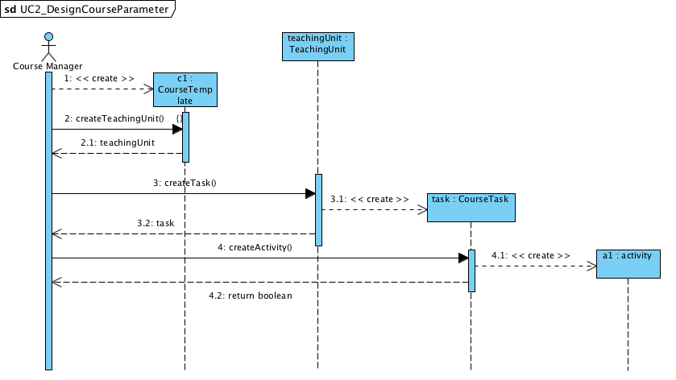

The diagram below shows the process of generating a management report.

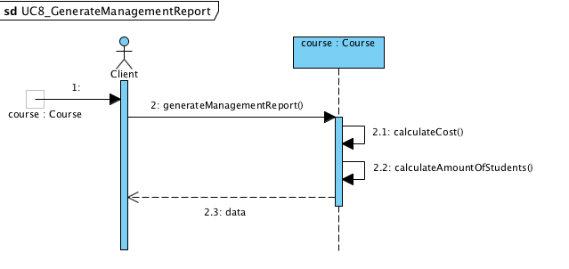

The following state diagram describes the state of the location when a course manager wants to add a preference of location type for an activity with required states for scheduling activities by the scheduling department.

